Practical 5: AWK COMMAND

Create a file empdata , which contains the following fields:-

Fieldname Datatype Value

1.emploee name character

2.emploee code numeric starts with letter ‘E’

3.department code character MKD,HRD,PUR

4.grade character A-C

5.designation character manager,director,gm,executive

6.years of experience numeric

7.date of birth dd-mm-yy

8.region character Pune,Mumbai,etc

9.basic play numeric

Insert atleast five records in the above file character fields may

or may not be same in the same case. ‘ ~ ‘is used as a field

separator

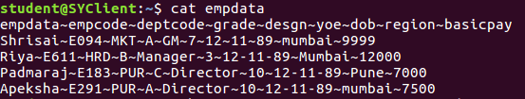

Give commands for the following:-

1.Display all employees who are Manager in office



2.List the details of an employee “Apeksha” in Mumbai office.



3.Display all employees who are not in the department MKT. Display the output sorted on the department code.

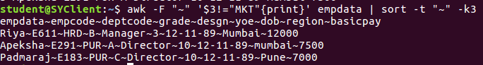

4.display all the employees whose years of experience are more than 5

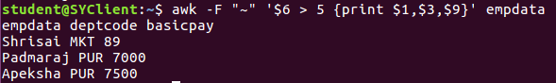

5.List only employee name, department code and basic pay of employees who are Director



6.Display all ‘employees’ having grade A



7.Count total number of employees whose department code is HRD

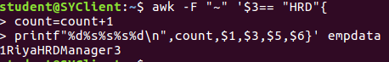

8.Display employees name with salary above 10000



9.Display only designation and basic pay of employees having

number of experience between 3 and 5



10.Find the number of employees in Pune office

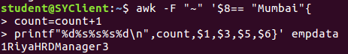

11.Display employees who get basic pay less than 15000,also

calculate and display average basic pay

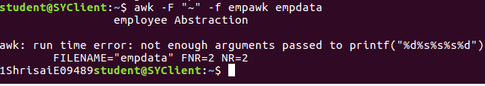

12.Locate the employees with same date of birth in Mumbai office.



13.Locate all for Riya,Apeksha,Padmaraj as employee name

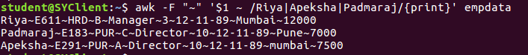

14.Locate all except for Riya,Apeksha,Padmaraj as employee name

